
PROPOSED TO MR. ABDUL RAFAY
A PROGRAMMER'S PERSPECTIVE

REPORT

2025

OOP PROJECT

MAKE IMPROVEMENT AND REACH YOUR GOAL
NSSI APPLICATION

PROJECT REPORT
INTRODUCTION:
NSSI stands for Namal Society for Social impact. This society Is providing services in various aspects of problems. Eight wings are part of this society; each have their own motive and tasks. We are making management software for this society. This software will help NSSI to manage their data and to perform its task in a better and efficient manner. We are making software which has its four wings, because these are the wings which should be managed in a better way. We have met with co-pattern of NSSI “Sir Mudassir Jatala.” He said, we are merging wings in the other because they have functionalities which are like each other. So, we merged them as Skill Development Wing in Education Wing. This software will manage four major wings of NSSI. They are given below.
- Education and skill development wing as one
- Blood Donation Wing
- Social Impact Wing
- Emergency Response and Assistance Wing
Objective:
Our main objective is to implement and enhance Skill in Object Oriented Programming. Second is to make flexible and brilliant software for NSSI. Third is to learn teamwork, how they work and coordinate with each other to complete a project and make a business successful. And last for the present to enhance our communication skills to present our projects and motive to a huge community. At the end of the semester, inshallah we will say they have given our best.
Team Members:
Our team has performed well and cooperated with each other and converted this hard road to soft for our goal and destiny. The names of our team members are mentioned below.
- Ahmer Sultan
- Shahbaz Ali
- Tayyab Shahzad
- Mishaal Aqdas
- Sundeep Kumar
Literature Review:
Our project is new and Fresh. This is practical software for NSSI Society. We are improving it to make a standard Software. There is no such review now. But, when it comes to use, then we will take reviews of NSSI team and after testing they will require improvements. Our target is to make it successful. So, it will reach height.

Working of the Wings and Implementations
We divided our work into five equal parts and then each member is assigned its duty. When we all done our work, then we merged our code in an efficient way.
- EDUCATION WING
Introduction:
Education Wing of NSSI is providing tuition to poor students. This is one of the main wings of society. Which is serving in Education field for the Society and the local community of Namal. In this software we will manage Attendance, Students, Members, and their tasks in this wing. NSSI is well disciplined in organizing their wings. So, this wing has its own team which is Serving the Society.
Developer:
This Wing is developed by Sundeep Kumar.
Features
- File handling
In this part of Software, we have a database, attendance management and duty allocation parts. Furthermore, if we come in database, we have team and student separated data to manage them easily. This software has flexibility in managing three main tasks of this society. In these three main tasks, we have more tasks if we go the options. In the database we can search, add, and display data of students and team. The data of students and team are stored in two different files (student.csv and team.csv)
- Attendance Management
Next this is its attendance, we are storing attendance of students in a csv file and can get data from this file. We can mark and display attendance of students. Attendance will be marked based on Dates. Then we stored this data in a file. After a long time, we can see the attendance of any student by going to the menu display attendance. We do not need to go to the file and check; we can directly display it with our program.
- Duties Management
Next thing is assigning Duties to team. As we have only members of mentor, mean team members are performing their duties as mentors. We are assigning subjects and days to each member. So, each member has a day to perform his specific duty.
- Skill Development wing
We have merged skill development wing in Education wing. This wing is only managing data for skill development class which is specified as Friday class. Students will learn a specific skill as per suggestion by skill development wing.
- UML Class Diagram
The UML class diagram is easy to understand any code. All our wings are separated; therefore, we have included a UML diagram of each wing just at the end of each wing’s implementation. Below is the UML diagram of Education Wing. This provides a clear concept to understand program code. It helps others to understand code and make changes.
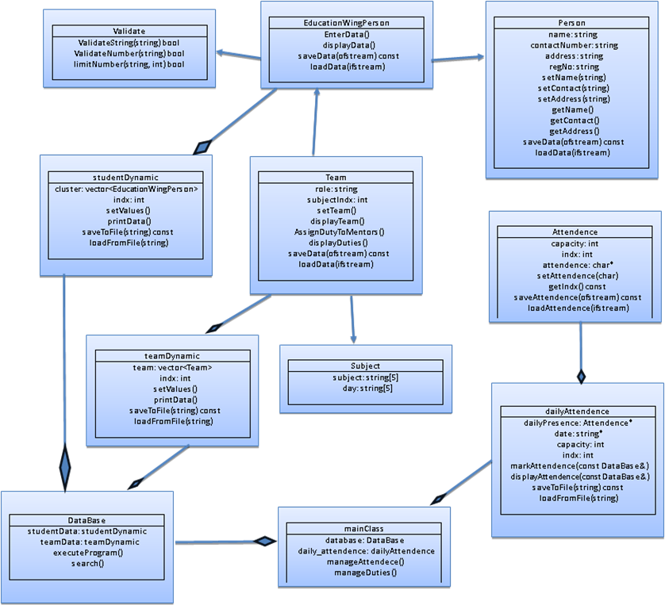

- BLOOD DONATION WING
Introduction:
One of the main services of NSSI is blood donation, which is most important and helpful to society and one of the most priceless works for the public of Pakistan. We wish to promote this to other universities as well. This wing has magnificent work for motivating students to donate blood for emergency cases. We are happy to share that this wing provides service to Meanwell, Chakwal, and Rawalpindi. NSSI has data of students’ blood groups with their contact information. So, whenever we were called for blood requirement, NSSI contact students who have this blood group. We really appreciate those students who donate their blood to save a priceless life.
Developer:
This Wing is developed by Tayyab Shahzad.
Features
- File handling
This wing stores data in files. In this wing. We are managing data of students and their blood groups along with their contact information. The data is for later use. In emergencies, we will contact the students who have the same blood group. For finding mail data, we involve search features in this group and a mail system from which we can send mails to students. Those who are willing to donate blood. We will take their detailed information and save it in a file for future use. We can edit, delete, or manage data from our software directly from files.
- Checkup
This software will ensure a proper checkup and procedure for blood donation. We will track all activities involved in this procedure. We will also have a proper record of students. This will be extremely useful. In the future, if NSSI wants an additional feature. We can add it.
- Reward for Donor
NSSI will give a reward to the student at the end who has saved a life. Of course, it is a best deed to save a life; this will inspire a student to play a vital role in the happiness of society. This is totally on NSSI, if they can manage then they will give rewards to donors.
- Mail System
We can contact a student or donor directly by sending them mail. We tried our best to implement a fully fletched system for mail. In this way it will be easy to contact on emergency situations to familiarize.
- largest Wing
This wing is the largest wing of NSSI society. This wing is extremely helpful for society to give a fruitful service to society. In a month NSSI society donates twenty-seven bottles of blood.
- UML Class Diagram
The UML class diagram is easy to understand any code. All our wings are separated; therefore, we have included a UML diagram of each wing just at the end of each wing’s implementation. Below is the UML diagram of Blood Donation Wing. This provides a clear concept to understand program code. It helps others to understand code and make changes.

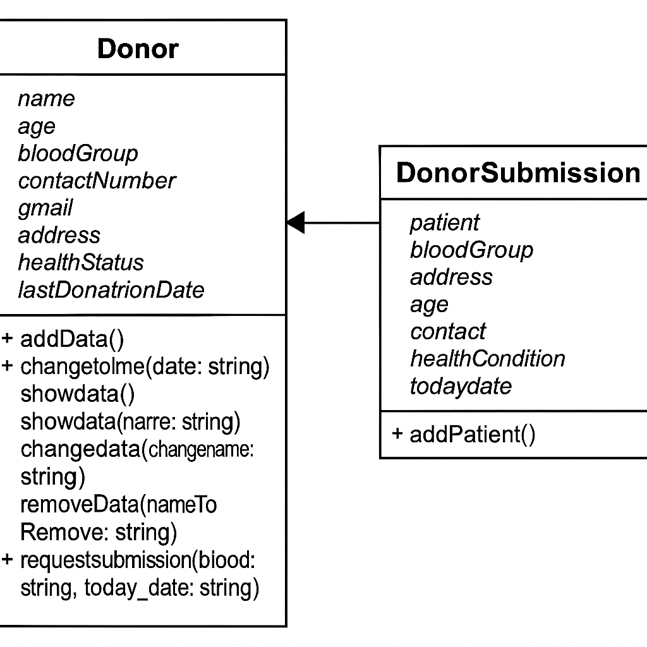

- SOCIAL AND WELFARE WING
Introduction:
This wing is providing social Assistance to the public. It is managing funds and social assistance to those who are effect by natural disasters. This is one of the wings who always play a significant role in public services. This wing has a special team who manages funds and provides food, refreshments, and assistance to poor people. This wing is managed by Namal Students and faculty and always tries their best to give their best to the people.
Developer:
Shahbaz Ali and Mishaal Aqdas develop this Wing.
Features
- File handling
Social impact society must have a complete record of the fund allocation. The well-trained team should genuinely manage this wing. They must keep records of every moment. This wing will generate a record base report. We will save data on every event which is served by society and the cost we spend on one event. This wing will store their team data.
- Project Data
We also track Project Data. We can make their report and have a record of all the projects. We can easily manage every project performance.
- Fund Management
The allocated fund to this wing is five lacs. This software has an amazingly effective fund management feature. We can add and use funds for every project. So, this will give a reliable and efficient feature to manage all funds. It is a very precise feature of the software.
- Services
This wing is providing health camp, food drives and disaster relief services. After the project completion will generate a report of this event and funds allocated to the project, how much used, how much returned to Society wing back. We will track all funds and project information. In this, the data of team members and their assigned roles has been managed through file handling. Team members of society can be added as well. The wing will help NSSI to manage its wing and funds. This will be especially useful. In the future, if NSSI wants an additional feature. We can add it.
- UML Class Diagram
The UML class diagram is easy to understand any code. All our wings are separated; therefore, we have included a UML diagram of each wing just at the end of each wing’s implementation. Below is the UML diagram of Social and Welfare Wing. This provides a clear concept to understand program code. It helps others to understand code and make changes.

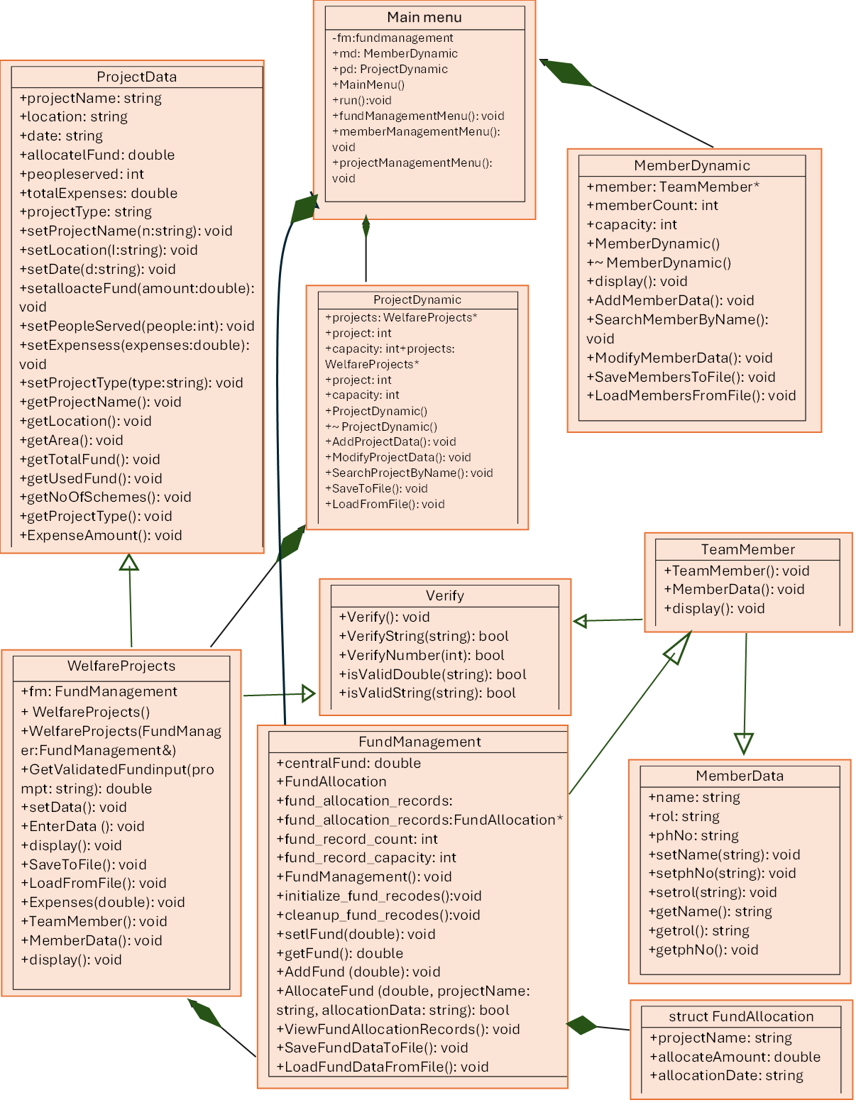

- EMERGENCY RESPONSE AND ASSISTANCE WING
Introduction:
Emergency Response and Assistance Wing is the wing which is giving service to the Namal Student. If there is an emergency and students need first aid or medical attention or even if there came a need to bring him to hospital this wing will serve students. This wing has a medical setup and medicine to serve students. If any student needs any assistance from this wing, they can easily avail by contacting this wing or direct to NSSI.
Developer:
Ahmer Sultan develops this Wing.
Features
- File handling
Emergency Response and Assistance wing genuinely have precise file handling techniques and tips to store and display data. It has a category wise data storage system. This wing is managing student and faculty emergency separately which will make it dependable to manage data efficiently. It has added, remove and search features.
- Student and Faculty management System
This wing is efficiently managing the student and faculty data. This wing is helpful to track all requirements and data handling.
- Emergency Response System
.it has a feature to save data of emergency cases. This wing will give aid and an assistant to the patient. It will manage the data of the patient and provide the best medical care to the patient. It will record data of patients. So, that it will be proof for university fund usage. This will be especially useful. In the future, if NSSI wants an additional feature. We can add it.
- NSSI Dispensary Management
This is one of the most brilliant features of the wing. It inspired us to have a special focus on this part of the wing. It will manage medicines, doctors, and other dispensary records. In this part of the software, we will manage the whole dispensary. We can add, remove, search, issue and save records. We can say we have a whole dispensary setup.
- Wing Services
This wing provides emergency services to faculty, students, and other staff. If they require blood. This wing can contact the blood wing. So, coordination of all the wings is necessary for their progress. This wing is fully dedicated to make progress and promote NSSI to whole Pakistan. This will give first ad to those who will face any accident in their life.
- UML Class Diagram
The UML class diagram is easy to understand any code. All our wings are separated; therefore, we have included a UML diagram of each wing just at the end of each wing’s implementation. Below is the UML diagram of Emergency Response and Assistance Wing. This provides a clear concept to understand program code. It helps others to understand code and make changes.

- 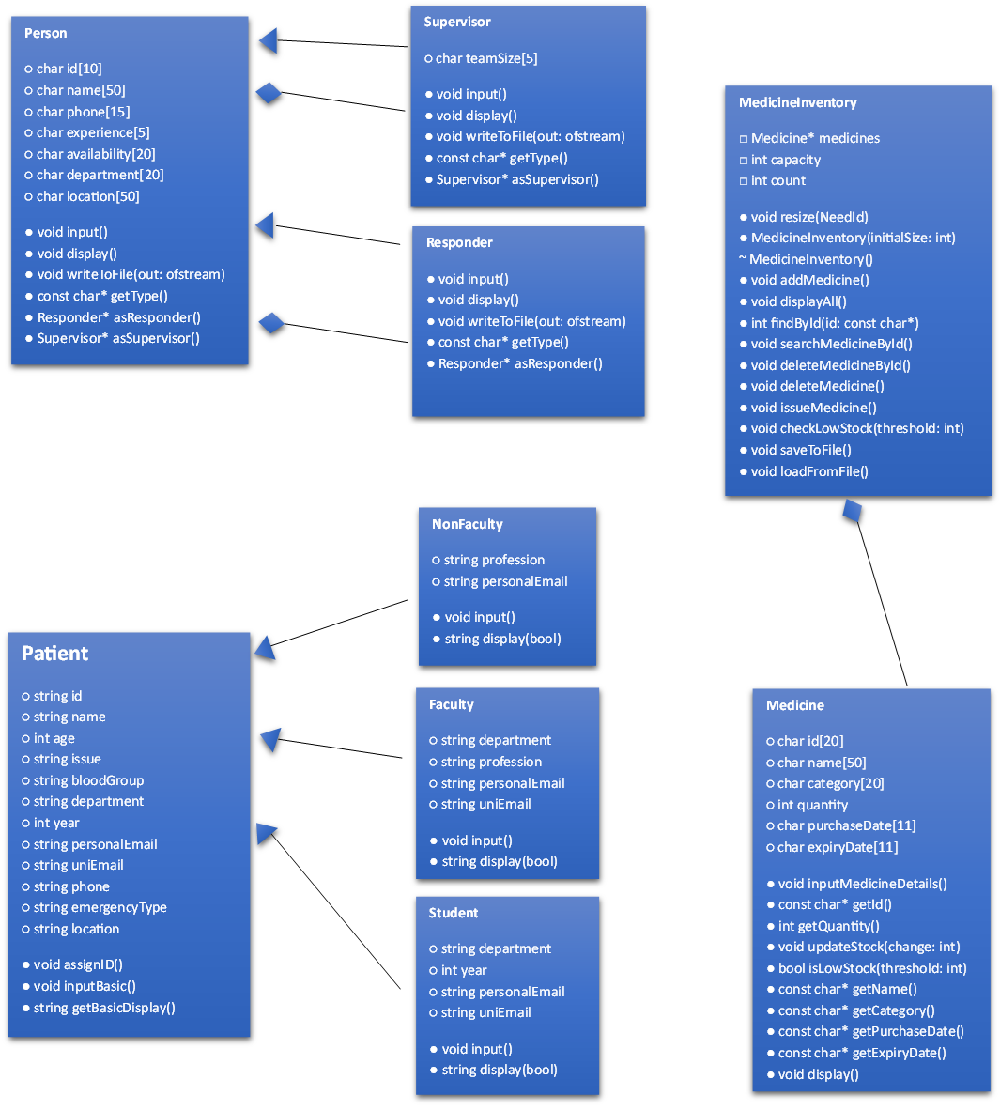

References:
- W3Schools (for basic syntax)
- www.programiz.com (for vectors)
- Chat GPT (for project overview)
- Gemini (code implementations)
- Learn C++ (for new topic selections)
Conclusion:
This project helps us to improve our programming skills, our critical thinking skills, our communication skills, and teamwork skills. This project was the second step to our Goal. We all enjoyed it well and really learned precious lessons from this project. This is a fruitful project toward our destiny and will be helpful in our career journey.

